## Knowledge Tree

1. Program structure.
   1. Include and namespace.
   2. Main
   3. Advantage
      1. OOPS
         1. Include and namespace.
         2. Function
         3. Variables
         4. main
2. Variable and types

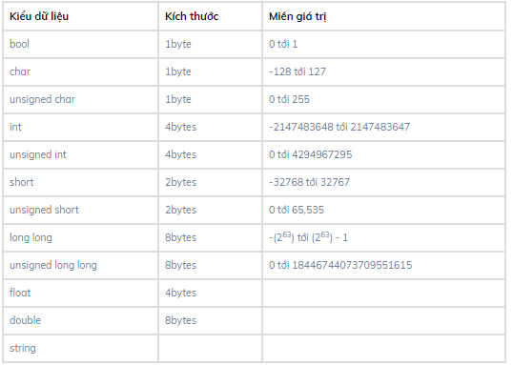

* Pressed type
* Constranst
* C++ IO.
* Operators.

1. Loop

* While
* Do while
* If else
* Switch case
* for

1. overloads and templates
2. Arrray
3. Class : OOPS
4. More